Facilitation Technique

1. Cooperative Learning Approaches
- Cooperative learning approach is one of teaching/learning approaches where students interact with each other to acquire and practice the elements of a subject matter and to meet common learning goals.
- Cooperative learning as a methodology in which “students learn with, from and for their peers”. It is an educational methodology based on working in small and usually heterogeneous groups, in which students work together to expand or hone their own skills and those of other group members (Johnson, Johnson & Holubec, 1999; Velázquez, 2010; Velázquez-Callado, 2012).
- The active participation of the students in the classroom discussion is always being encouraged to strengthen not only the cognitive ability of the learners but also the affective and psychomotor domains. Students are involved in solving problems, brain storming, formulating questions on their own, discussing ideas and expressing opinion on debates. Giving them the chance to take part in team exercises enhances their capacity to become leaders and be responsible in performing their assigned tasks.
Introduction
- The 21st century approach is learner-centered and activity based. The different methods or approaches a facilitator can use in facilitation outlined herein are cooperative learning,
- Experiential learning, individualized learning, and facilitator guided whole class facilitation. During teaching and learning, appropriate facilitation methods/technics are to be applied to achieve set learning objectives/session objectives for the effective implementation of Competency Based Curriculum (CBC).
- In implementing innovative pedagogy approach in a 21st century implies that the role of a teacher will change to a facilitator which indicates a shift from a teacher-centered to a learner-centered approach to learning
1. Cooperative Learning Approaches
- The term cooperative learning refers to students working in teams on an assignment or project under conditions in which certain criteria are satisfied, including that the team members be held individually accountable for the complete content of the assignment or project (Felder & Brent, 2007). Collaboration among the group members improves the skills of the students to communicate in social discussion and participate in the accomplishment of their common goal.
- Cooperative learning offers a pleasant learning situation for all students, all students have equal opportunity, competition is amended as friendship, the spirit of cooperation and participation is reinforced, and all students are entitled to be thoughtful and creative (Keramati, 2001; Lavasani & Khandan, 2011). Teacher can encourage students to ask for help to better understanding of the difficult subjects through forming cooperative groups; on the other hand, students will learn to ask for help in different occasion whenever help seeking transpires (Lavasani & Khandan, 2011).
1. Cooperative Learning Approaches
This cooperative learning approach has the following basic elements (PIGS Face)
- Positive inter-dependence
- Individual accountability
- Group processing
- Social Skills
- Face-to-face interaction
Cooperative learning approach has various methods but not limited to:
- Brainstorming (A)
Brainstorming is a method for developing creative solutions to problems. It works by focusing on a problem, and then deliberately coming up with as many deliberately unusual solutions as possible and by pushing the ideas as far as possible. In situations, often related to problem solving, to generate possible solutions.
1. Cooperative Learning Approaches
However, for effective brainstorming sessions:
- Ideas should flow freely
- Aim for quantity, not quality of ideas
- Record every idea clearly
- Do not criticize or evaluate ideas in the session
- Consider an independent facilitator to the group
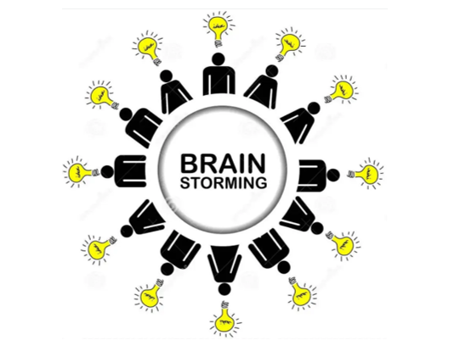

1. Cooperative Learning Approaches
- Think – pair –square – share (B)
Learners first work on a given problem individually, then compare their answers with a partner and synthesize a joint solution. The pairs in turn share their solutions with other pairs and the squares with the whole class.
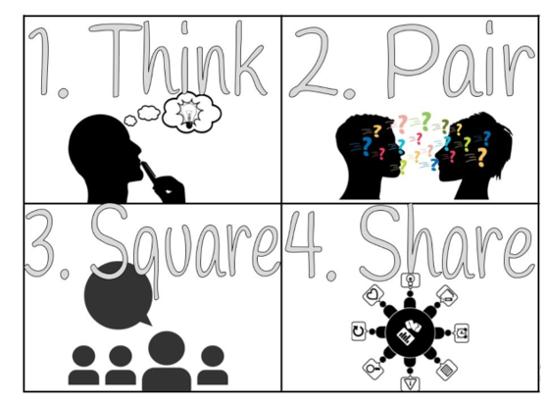

1. Cooperative Learning Approaches
- Group discussion and plenary session (C)
Learners are actively involved in talking and listening to each other about an issue of mutual concern. A leader guides the situation.
Group discussion is a learner- centered strategy, in which students are divided into groups and they are encouraged to discuss on the subject matter given.


1. Cooperative Learning Approaches
- Round table (D)
Facilitator/teacher poses a problem with many possible answers, and then students make a list on one piece of paper using one pen, each writing one of the possible answers and then pass the paper to the next person. The paper literally goes round the table and the end outcome is presented to whole group/class.
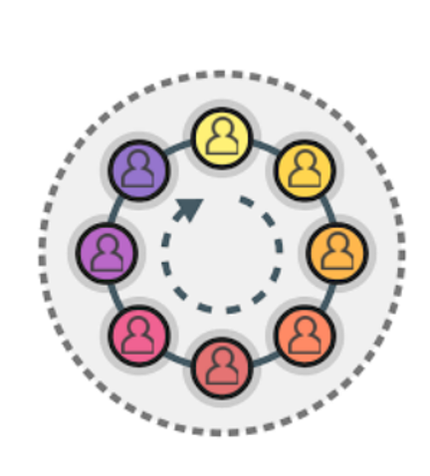

1. Cooperative Learning Approaches
- Four corners (E)
A method used to make learners take a stand on a controversial issue. Four corners are labelled STRONGLY AGREE, AGREE, DISAGREE, STRONGLY DISAGREE or otherwise. Groups in the corners are asked to clearly justify their point of view.
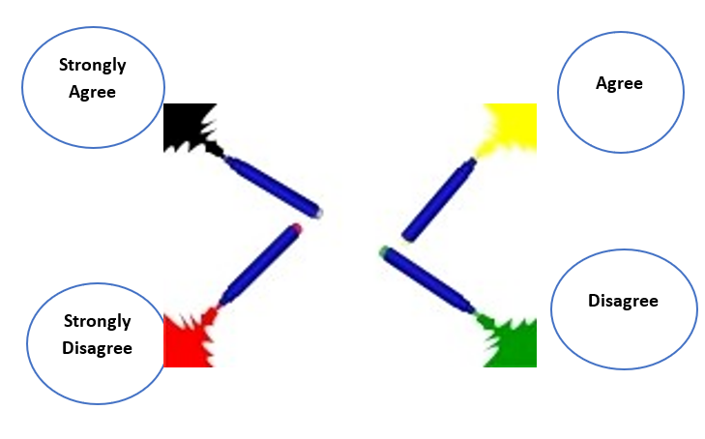

1. Cooperative Learning Approaches
- Role plays (F)
Role-play has students practice a skill in the whole class or in small groups. The audience is important as it expected to critique the performance. In most cases there is no right or wrong. The role players should describe the evaluation criteria as they envision them. All must participate as those who are not in the role-play must actively critique the performance
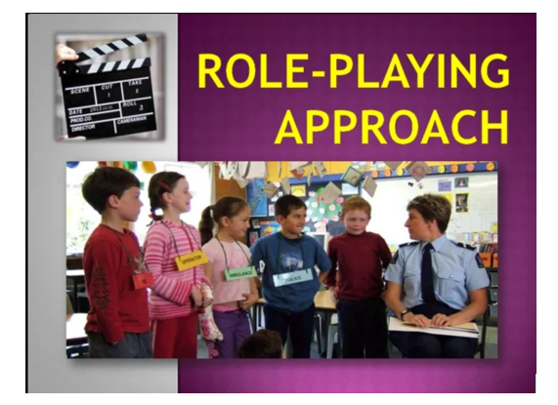

1. Cooperative Learning Approaches
- Simulation (G)
This is a more elaborative version of role-playing, with structured rules and game-like arrangements or ‘real’ situations are created by technology (computer simulations / flight simulator).
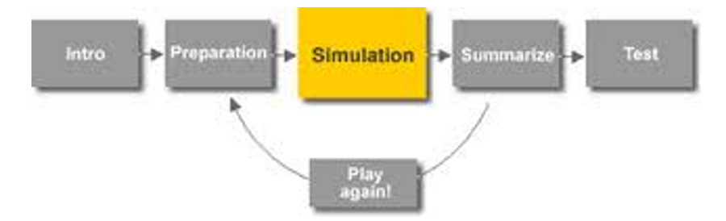

1. Cooperative Learning Approaches
- Jig saw (H)
Learners work together in small groups where they rely on each other to complete a task. Each member of the group becomes an ‘expert’ in a topic and is to pass this expertise to the other members of the group.
- Divide the material needed to cover a topic into roughly equal parts.
e.g., you might assign four different articles, the number of parts determines the number of learners in each home team group.
- Form the home groups and number within each home group.
- Assign a different topic to each home team member.
- You make the assignment: for example, all #1's will read the article A, all the #2's will read the article B, all the #3's will read the article C, and all the #4's will read the article D.
- Expert return to home groups. Each expert is given 5 minutes to explain the topic of specialization to the other members.
1. Cooperative Learning Approaches
Jig saw (H)
6. Work in expert teams: all experts with the same home number sit together and go over the material assigned to them (guiding questions at the end of the article will help). They ensure they understand the material and agree on how ‘to teach’ the material to their home team members. Consult with experts from other teams. Set time for work in the expert groups.

7. A quiz, to be answered individually is set to check that the learning has taken place.
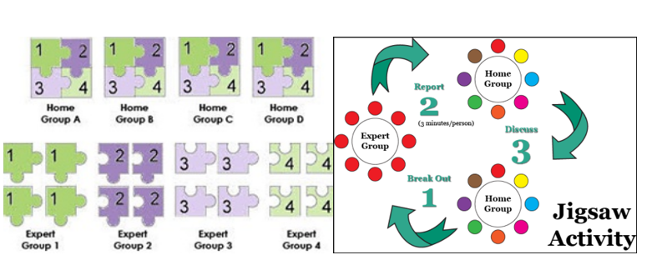

1. Cooperative Learning Approaches
Inner and outer circle (I)
- A method to exchange information related to previously taught material or to obtain views from peers (learners have flash cards on the topic to be reviewed)
- Learners stand /sit in two concentric circles, with the inside circle facing out and outside circle facing in. They make a quarter turn to the right and then march or rotate past each other. The teacher defines how many people they must pass before they stop. When they stop, they turn and face the person they are paired with and discuss the set task. After a set time (2 – 5 minutes) the outer circle moves a given number of places to the right to face another person and discuss the same issue with the new partner. This can be repeated a number of times.
- Learners in the inside circle show the question to their partner. He/she answers the questions. If answer is not correct (the answer is on the other side of the flashcard) partners discuss the
- Correct answer. Next the person in the outer circle shows his/her flashcard question to the partner in the inner circle. Circle turns to make new pairs.
1. Cooperative Learning Approaches
Inner and outer circle(I)
A method to exchange information related to previously taught material or to obtain views from peers (learners have flash cards on the topic to be reviewed)

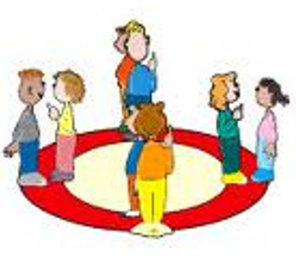
1. Cooperative Learning Approaches
Debate (J)
A pro-and cons discussion of a controversial issue (both groups should have about the same number of learners). This method is used to convince the audience rather than to display skills in attacking the opponent and best used to:
- Help students to see biases that they hold and provide a strategy for changing those biases
- Assist students in public speaking skills

1. Cooperative Learning Approaches
Case Study (K)
- The examination of a real or simulated problem which is structured so that learning can take place. Cases need not be literal accounts of actual incidents (though they may be); however, the characters, situations and dilemmas described must ring true and represent experiences so as to prompt meaningful discussion.
- Complex and information-rich, cases depict incidents that are open to interpretation—raising questions rather than answering them, encouraging problem solving, calling forth collective intelligence and varied perspectives.
- Cases include elements that could not be contrived in a simulation / role play; frequently used in cases in which something went wrong. Learners are to (i) analyse what went wrong and why (ii) suggest ways how the problem / failure could have been avoided.

- Groups are provided with the case study notes, groups prepare their own solution / response to the problem(s) presented, presentations and plenary are done, finally the summary is done by facilitator/teacher.

1. Cooperative Learning Approaches
Seminar (L)
- A group discussion in which a learner presents a topic, usually of a controversial or provocative nature.
- One member of the group prepares a presentation (prepared well in advance under supervision of facilitator). [Guest speaker can also be used].
- The group discusses in depth the presentation (members have done prior reading on the topic). Learners may be reluctant to critical evaluate a peer.
- There is a need of summarizing main issues at end of seminar to ensure learning to take place.

2. Experiential Learning Approach
- This method gives people opportunity to learn from their experiences. Kolb (1984) described this process in 4 stages otherwise called the four stages of experiential learning namely concrete experience, reﬂective observation, abstract conceptualization and active experimentation.
- Many skill-oriented topics in the syllabus can be covered using the experiential learning cycle. For example, baking cookies (with no recipe), building, and throwing a paper airplane made from an A4 paper, and mixing paint, among others.
- What the activities have in common is (i) an experience – which can be trial and error, viewing a demonstration (ii) reﬂection on the experience, processing the experience (iii) thinking of ways to get a better outcome / result and (iv) testing out the ideas.
- Experiential learning is referred to as learning through action, learning by doing, learning through experience, and learning through discovery and exploration.
2. Experiential Learning Approach
It is a methodology in which teachers purposefully engage with students in direct experience and focused reflection to increase knowledge, develop skills, and clarify values.
3.Individualized Learning Approch
- Individualizing instruction involves providing different learning tasks for each learner and support at the individual level. It is based on the idea that all learners are different and have different needs, have different abilities, interest, learning styles.
- An individualized learning approach is a personally tailor-made approach particularly in terms of the learning tasks and activities, assessment task and the pace at which leaners make progress in the learning programme.
- Each learner follows his/her own learning paths. Individualized learning is considered to be more effective, as it addresses the needs and preferences of each individual learner.
- Appropriate use of digital technologies has opened pathways to facilitate individual activities, assessment, and feedback. The most common models for individualized learning are: directed study of materials in textbook, handouts; print or online self-study material; e-learning; assignments /projects.
4. Facilitator Guided Whole Class Learning Approches
Facilitator guided learning sessions known as also as trainer guided learning approach, and other sessions also, can easily turn into a lecture. Teachers are used to the lecture approach that in any situation might revert to ‘lecturing’. Lecturing is a one-person show, one person talks to a group with little or no interaction between the speaker and the audience.
The following are the phases through which this approach is conducted:
Phase 1 Clarify the purpose of the lesson/session
The teacher clearly explains the learning objectives and learning outcomes for the session and explains how they fit into the topic/course as a whole.
Phase 2 Review previous learning

The teacher reviews through question and answer, the key learning points of the last session, and any homework. The review covers both ‘how’ and ‘why’ to consolidate learning and link new learning to previous learning.
4. Facilitator Guided Whole Class Learning Approches
Phase 3 Present new material
- The teacher ‘demonstrates’ (e.g. how to make a scale drawing; using of standard lettering; drawing electrical symbols; calculations involving new content and checks that learners understand (NO lecture, but interactive explaining / demonstrating, PP-slides can support), using concrete examples from learners’ lives wherever possible.
- During the ‘demonstration’ the teacher explains clearly and carefully, describing the process, both ‘how’ and ‘why’, and explaining by ‘thinking out loud’ throughout the ‘demonstration’, involving through questions the learners at all times. The teacher could work through the task, with the learners telling the teacher how to do it.
Phase 4 Transition from demonstration to independent practice
- To aid the transition from demonstration to independent practice, individual learners work at some controlled practice activities that apply the concepts and skills demonstrated. The teacher checks and corrects any errors at this stage.
4. Facilitator Guided Whole Class Learning Approches
Phase 5 Apply this new learning with a learner activity
Learner activity should comprise the majority of the session. Learners should work individually (although assisting each other – pairs – is fine) with supervision as required. The teacher checks and corrects learners’ work and provides positive feedback. Teachers could ask learners to check and review each other’s work.
Phase 6 Review the skills learned in this session
The teacher asks the learners to formulate the key points they have learned and what they still need to learn.
The review covers both general concepts and methods, ‘how it’s done and why it’s done that way’. The teacher uses question and answer to elicit, confirm, and correct the learner summaries of key points and relates these to the lesson objectives.

CBT Sessions Delivery
The sessions are highly recommended to be delivered with the following three (3) stages: (1) introduction, (2) development, and (3) conclusion. At the introduction stage, TVET teachers are expected to introduce learning objectives, topics, activities, and resources for their sessions.
Then, learning activities are expected to be conducted to achieve learning objectives in the development stage. At the last stage of conclusion, TVET students are summarised of what they learnt, which is often followed by formative assessments that evaluate whether learning objectives are achieved. After their sessions, TVET teachers are recommended to have session reflections to improve the quality of session facilitation.

